HISTORY SNIPS FROM THE BRANSCOMBE PROJECT – JULY 2020
Geoff Squire, son of the old school-master, is back. This time describing a war-time hair-cut …
MR FREDDY DOWELL (1869-1954), OUR FRIENDLY BARBER AT WOBBLE
I’m writing about Mr Dowell after 16 weeks of lockdown due to the Covid-19 virus. After four months with no haircuts, my hair is very long and untidy - I could do with his services today! In some ways this situation is similar to Branscombe in the early 1940s when, as a young boy locked down by the war, I didn’t leave the village for years. This heightened experience of Branscombe’s life and its surroundings left a lasting impression. At least my father, my brother Kingsley and I had the freedom to walk over to Wobble on Lockseys Lane for our haircuts, without appointments or ration books.
By that time, Mr Dowell was elderly and rather lame, but he was still doing a lot of gardening as well as cutting hair. Gents only - as far as I know. Married in Branscombe Church in April 1902, Mr Dowell and his wife, Susan (1864–1946), had been living at Wobble with its lovely woodland backdrop since Edwardian times. At the time of the 1911 census Mr Dowell was a coachman and they had two children, Ernest 7, a pupil at Branscombe School, and Ellen 5. Sadly, Ernest died in 1914 age 10 and Ellen in 1942 age 36.
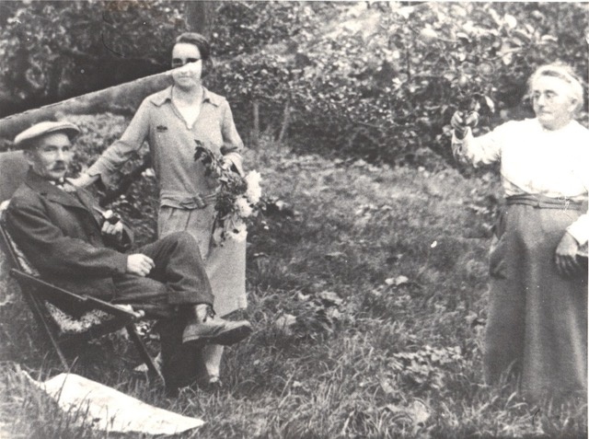
Fred Dowell dressed in his best suit. Maybe it was his birthday, or maybe … who knows? His daughter Ellen has a bunch of flowers, his wife Susan is holding the mynah bird.
In his younger days Mr Dowell had various jobs in Branscombe: miller’s boy, servant, butcher and groom. What stories he could have told us about Branscombe in late Victorian and Edwardian days, but when we went for our haircuts he chatted to my father about current topics, which also arose when my father met Harry Layzell the blacksmith or John Perry the postman. Gardening and the weather always came up, usually linked together. ‘Grow your Own food’ and ‘Dig for Victory’ were familiar wartime mottoes and it seemed that everyone was involved with gardening, so there was a lot of talk in warm Devonian tones about crops, soil, rain and the “ween” (wind). I imagine that “vraust” (frost) also came into it from time to time. The state of the war and goings-on in the village were other matters for discussion. All this often formed a lengthy prelude to the real purpose of our visit.
We drifted towards Mr Dowell’s hair salon. It was in his “linney” (linhay) - an old, open-fronted shed close to his front door. The linney held a ramshackle collection of tools, gadgets, pots and pans and all sorts of rusty odds and ends. I imagine that most of Branscombe’s old timers had a shed like Mr Dowell’s - we had one at the schoolhouse, just storing lots of stuff. A strong whiff in Mr Dowell’s linney suggested that he kept his paraffin somewhere in its dark recesses - fuel for his portable lantern. I expect that Mr Dowell kept his lantern light low during the wartime blackout, but I doubt if the Air Raid Precautions Warden (probably Mr Lloyd of Barnells), made many visits to Wobble to check on any infringements of the blackout regulations.
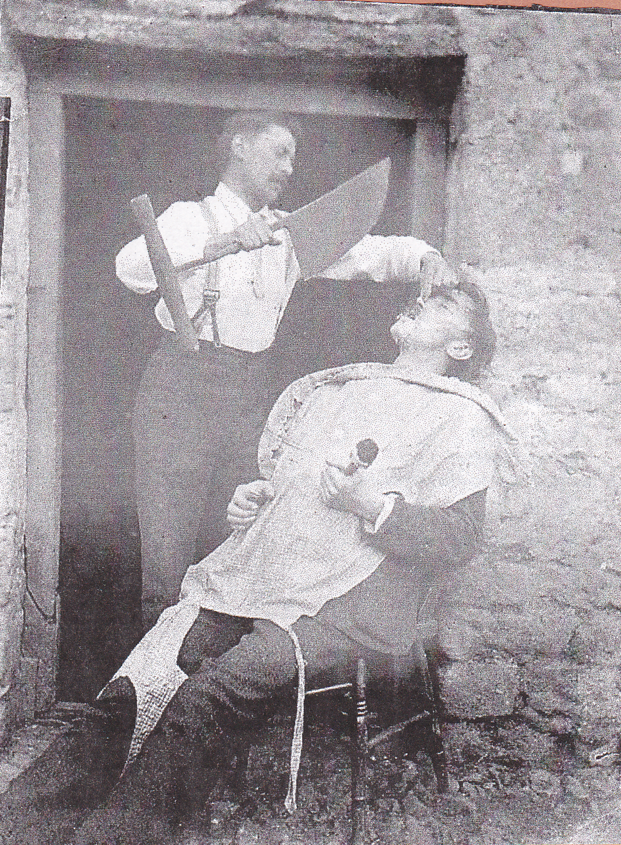
Things always moved slowly at Wobble. Mr Dowell was not a driven man - he took time to find his apron, scissors and hand clippers. When he placed his chair at the entrance to the linney, where there was sufficient daylight, we knew that he was ready for our haircuts - but not until Kingsley and I agreed about who was going first! It was a short back and sides haircut, so Mr Dowell began his performance by snipping away with the scissors, starting just above your right ear. Then he slowly worked clockwise around your head snipping, wheezing, still talking about gardening and the weather. Next, he moved in with the clippers - very cold against the back of your neck. By the time he had given the top part what he called a proper cut, you ended up with a pretty severe haircut: “Dowell Style”as my mother called it when we got home. Later on I heard about layering, thinning, styling and fashions, but it must be said that Mr Dowell succeeded in keeping our hair under control during the war years when there were few barbers around.
When Kingsley and I were done it was my father’s turn. By the early 1940s he had lost most of his hair so his haircut didn’t take long, but while he was in Mr Dowell’s chair and they were still going on about
Will Pike getting a shave
outside the Masons Arms

gardening, we usually had enough time to nip down, drop stones into Mr Dowell’s well and wait for the splashes - big ones and little ones. We liked this little game, but one day when we were down there my father suddenly appeared - caught in the act! We were given a good telling off and we had to say sorry to Mr Dowell.
Recent Branscombe Project research by John Torrance on Branscombe in the Middle Ages (available on the project’s website), shows that in the Middle Ages, Wobble or Wabbewell as it was called then, was owned by the farming families who lived at Hole House, just across the valley. I imagine scenes with Elizabethan and
Will Pike getting a shave outside the Masons Arms
earlier people strolling along the sunlit path we often followed between these two places - down the slope....across the stream....up the other side....chatting away.... singing.... Was the well at Wabbewell the one where Kingsley and I were caught dropping stones?
Our wartime visits to Wobble never led us to such flights of fancy – but they certainly left us with memories.

